Name:______________________ Class:________
WEEK 6
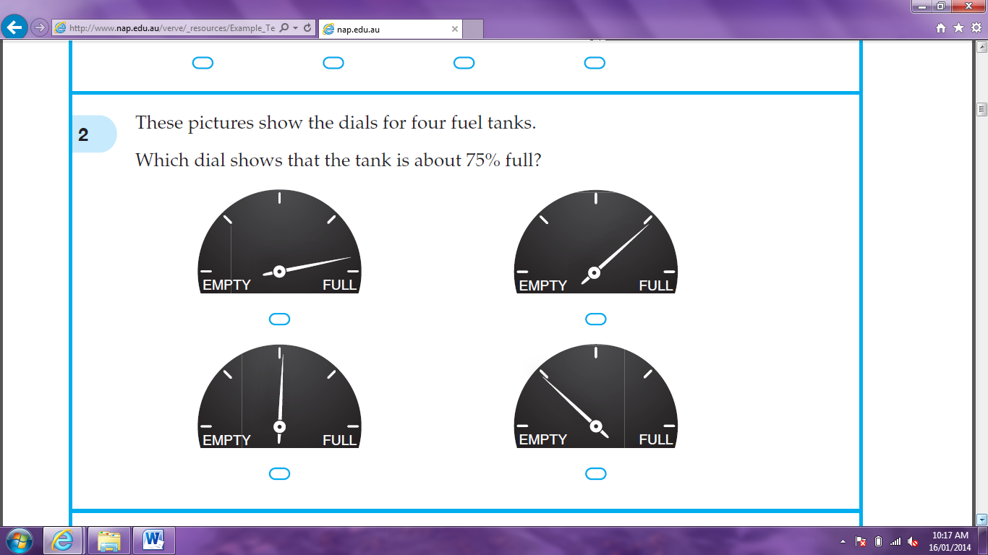

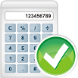
- These pictures show the dials for four fuel tanks. Which dial shows that the tank is about 75% full?

- Jenna bought a dozen oranges for $10.20. What was the average price per orange?

- The graph shows the number of computers in all the houses in a street. How many computers were there, altogether, in the street?

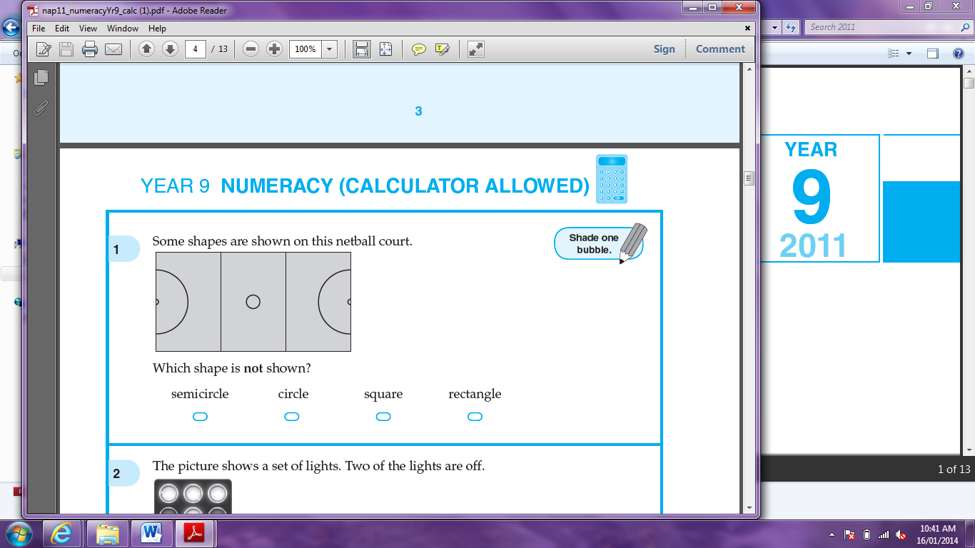
- Some shapes are shown on this netball court. Which shape is not shown?
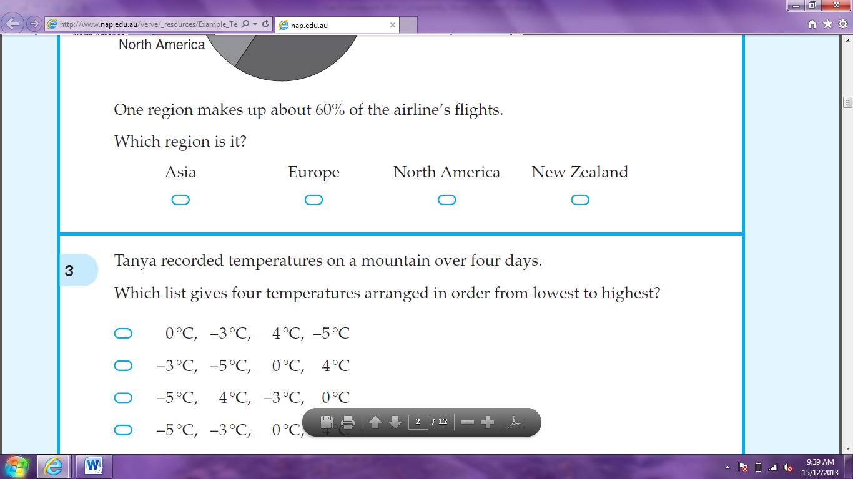



Semicircle circle square rectangle

- When Eli moved to Australia, the population was 22 112 277 people. How many people is that to the nearest million?


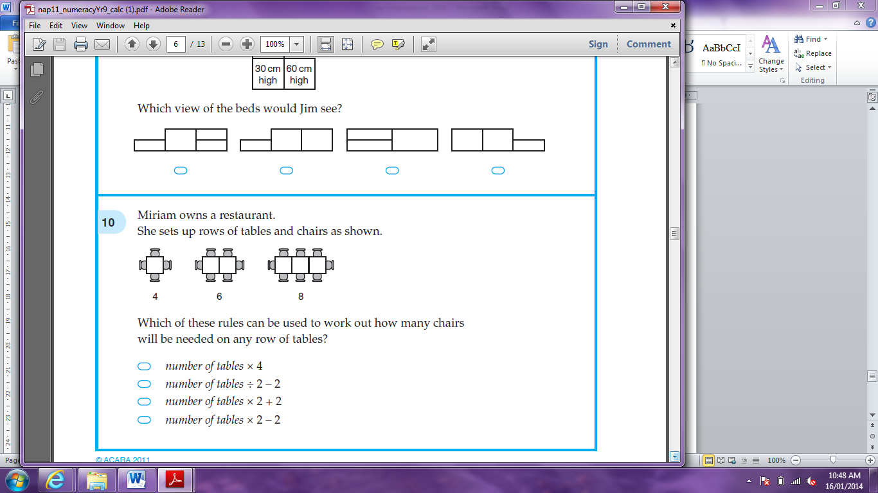
- Miriam owns a restaurant. She sets up rows of tables and chairs as shown. Which of these rules can be used to work out how many chairs will be needed on any row of tables?

Number of tables x 4

Number of tables ÷ 2 - 2

Number of tables x 2 + 2
Number of tables x 2 – 2

- What is the number 2 less than x?




- -2x 2 – x x – 2 -2 – x

- A rectangle has a perimeter of 24 metres. The shorter sides are 5 metres long. How long are the longer sides?





- Two bricks can be placed together face-to-face to form three different rectangular prisms. Two of them are shown below. Which would be the measurements of the third prism?
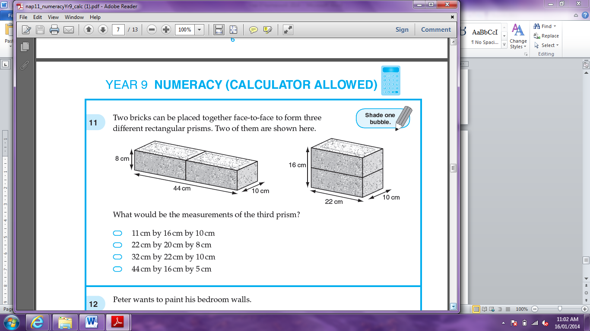
11cm by 16cm by 10cm
22cm by 20cm by 8cm
32cm by 22cm by 10cm
44cm by 16cm by 5cm

- Consider these scores: 3, 5, 5, 8, 12. Which changes if the score of 8 is removed?




mean median mode range

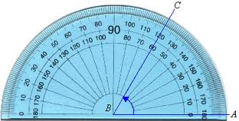
- What is the value of ?

- What is the size of ?

- The cost in dollars to print n books is 500 + 10n. How many books are printed for a cost of $15 000?

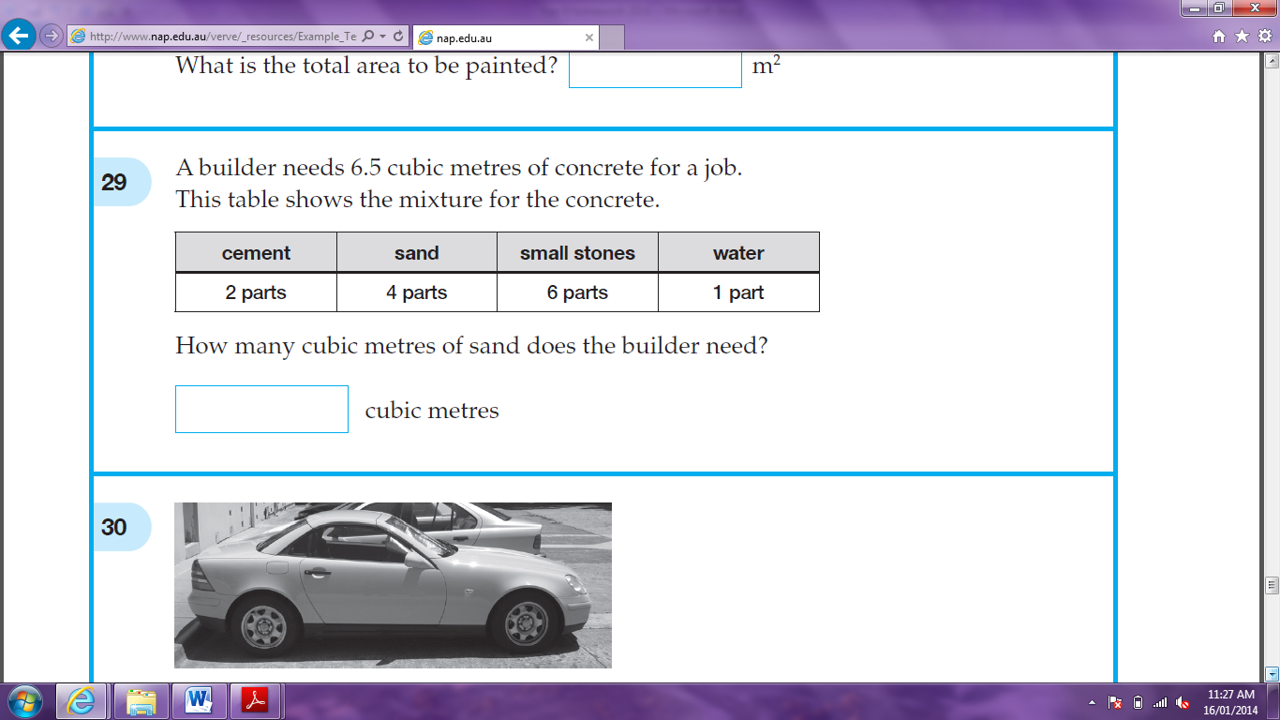
- A builder needs 6.5 cubic metres of concrete for a job. This table shows the mixture for the concrete. How many cubic metres of sand does the builder need?

- When t = -2, what is the value of 3t²?

- What is the smallest number that is a multiple of both 12 and 15?

- In this drawing, ACD is an isosceles triangle and BC = DE. What are the sizes of the two marked angles, d and e?
